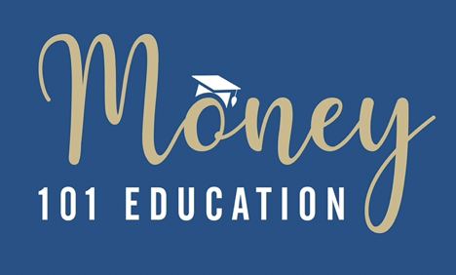

Please answer the below questions in your own words.

Type or write your answers into the box. Please save the file with a title that includes the date (AND your name. i.e., 2024-07-31 Sally’s Homework and email to Diane.Drey@scorevolunteer.org

Looking at Handout 12.0 instructors’ notes is not cheating.

HERE WE GO….

|  |  |  |
| --- | --- | --- |
| 1. | What is a bond? |  |
| 2. | What factors should you consider when buying a bond? *(hint we discussed four factors)* |  |
| 3. | What is a Bond “rating”?  Give examples of ratings? |  |
| 4. | What is a Bond “term”? give examples of short-term, mid-term, long term |  |
| 5. | What is a Bond’s “Face value”? |  |
| 6. | When interest rates go up, what happens to bond prices? |  |
| 7. | When interest rates go down, what happens to bond prices? |  |
| 8. | In 2021, Jane purchased a $10,000 bond with a 5-year term that pays 3% interest.  Jane will receive $300 interest annually for five years and then get back her $10,000.  Two years have passed, and Interest rates have risen. Investors can buy a similar bond and earn 5% interest.  What must Jane do to attract a buyer to purchase her 3% bond? |  |
| 9. | How much would a buyer offer to purchase Jane’s bond?  Remember, there are three years left on which the 3% bond will pay interest. | *This is a HARD BONUS QUESTION* |
| 10 | In 2021, Veronica purchased a $10,000 bond with a 5-year term that pays 8% interest.  Veronica will receive $800 interest annually for five years and then get back her $10,000.  Two years have passed, and interest rates have dropped. Investors can now only earn on a similar bond 3% interest.  What will Veronica do if she wants to sell her bond? |  |
| 11. | How much would a buyer offer to purchase Veronica’s s bond?  Remember, there are three years left on which the 8% bond will pay interest. | *This is a HARD BONUS QUESTION* |
| 12 | What is the critical factor in determining your stock/bond ratio? |  |
| 13. | When someone says I need to make my portfolio “more conservative,” what would they be decreasing and what would they be increasing? |  |
| 14. | What is another word for Stocks? |  |
| 15 | What is another word for Bonds? |  |
| 16 | Fill in the blank: | Stocks pay_____________ and Bonds pay______________ |
| 17 | Look at handout 12.02a. What is your RETIREMENT account's suggested stock/bond ratio now? |  |
| 18 | In ten years, what will be your RETIREMENT account’s diversification ratio? |  |

**YOU ARE NOT DONE YET….**

**READ AND REVIEW**

* 12.02 Recommended Diversification (a) retirement (b) college savings (c) life fund *
* **12.03 How to put together a portfolio of stocks and bonds** – *this is what we will discuss in class #3, and we will begin to do Morningstar research*
* 12.06 Bonds – How is interest paid on US Savings Bonds Series EE
* 12.07 Bonds – How is interest paid on most government and Corporate Bonds

*\* 12.02 is the most critical handout for the Investment segment – if you only keep one handout this is the one*