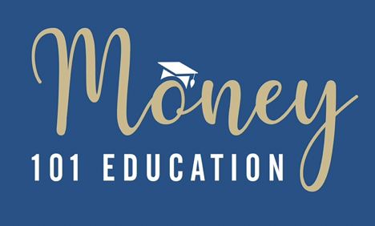

**As I have been teaching women about money for several years, I often ask:**

**What do you wish you had known about money earlier in life that you know now?**

Here are some responses.

As I grew up, there was never a positive conversation about money from my parents. So much fear and anger were all I saw. So, there was never a calm place to discuss money and how to have a positive relationship with money. (Laiya)

I enjoyed the statement about focusing on increasing your income. I was taught to "cut back." (Laiya)

I wish someone had taught me about credit cards and the consequences of keeping a balance & interest. I wish l knew how to budget and invest my money instead of being in debt and could have a healthy retirement. This should be taught to all young people starting at age 12. (Marcha)

Don't use being an immigrant as an excuse not to become educated about money. A lot of American folks have also had to educate themselves – from s. I can seek resources or support from caring experts like Diane to guide me. Knowledge is truly empowering. Clarity is kind. (Rei)

Investing doesn't have to feel like a reckless gamble or rocket science as long as I approach it as a long-term thing. (Rei)

I can approach the topic of money with curiosity instead of something to determine my self-worth. (Rei)

I wish I'd known the mechanics of investing. I was taught the importance of savings, but whenever the topic of investing was brought up, there was more talk about the risks rather than the rewards. Luckily, I didn't inherit an aversion to investing, but I didn't know how. In college, I invested in some mutual funds by way of the university's credit union, but I wish I'd been more versed in self-directed accounts and how to assess what constitutes a wise investment. I now tell people that finance keeps people out with the two Ts: technology and terminology. Both make it seem unapproachable, but it's not as difficult as people make it out to be. (Brandi)

I wish I had known the importance of building a solid emergency fund earlier. I put all of my disposable income into retirement savings. So, when disaster struck and I was laid off twice, my emergency fund was not robust enough, and I survived by tapping into retirement income. (Natalie)

I wish I had known earlier in life what it takes to be a homeowner and how to buy investment properties (Natalie)